SHMYO Öğrenci Sınav Değerlendirme Anketi-Güz Dönemi_Ara Sınavlar
Link: https://forms.gle/mrU2USWDBf5UNgqw7
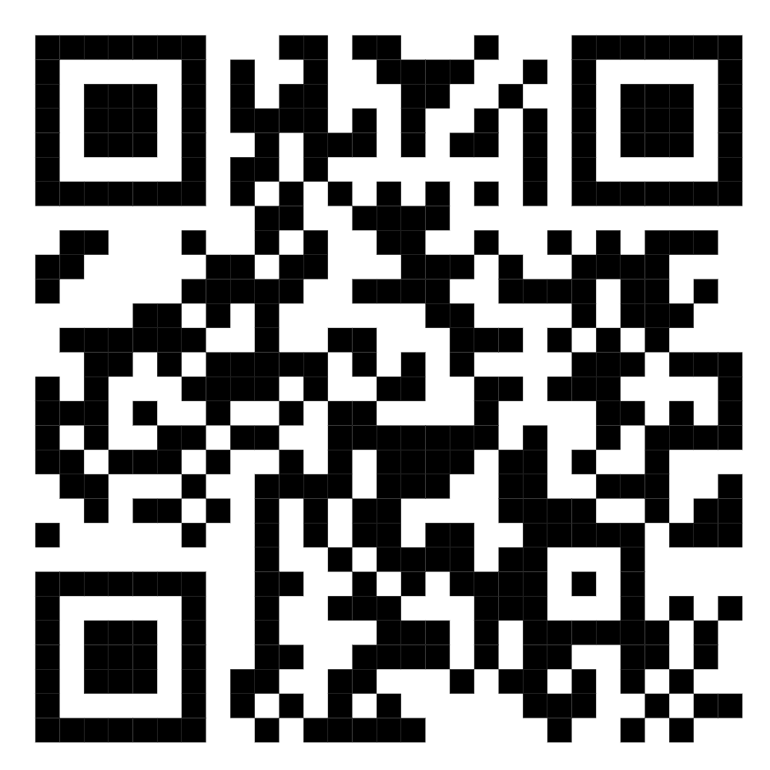
Şekil 1: SHMYO Öğrenci Sınav Değerlendirme Anketi Kare Kodu

Vocational School of Health Services Student Exam Evaluation Survey – Fall Semester_Midterm Exams
Link: https://forms.gle/ChpaY8rNFVwzcDXh8
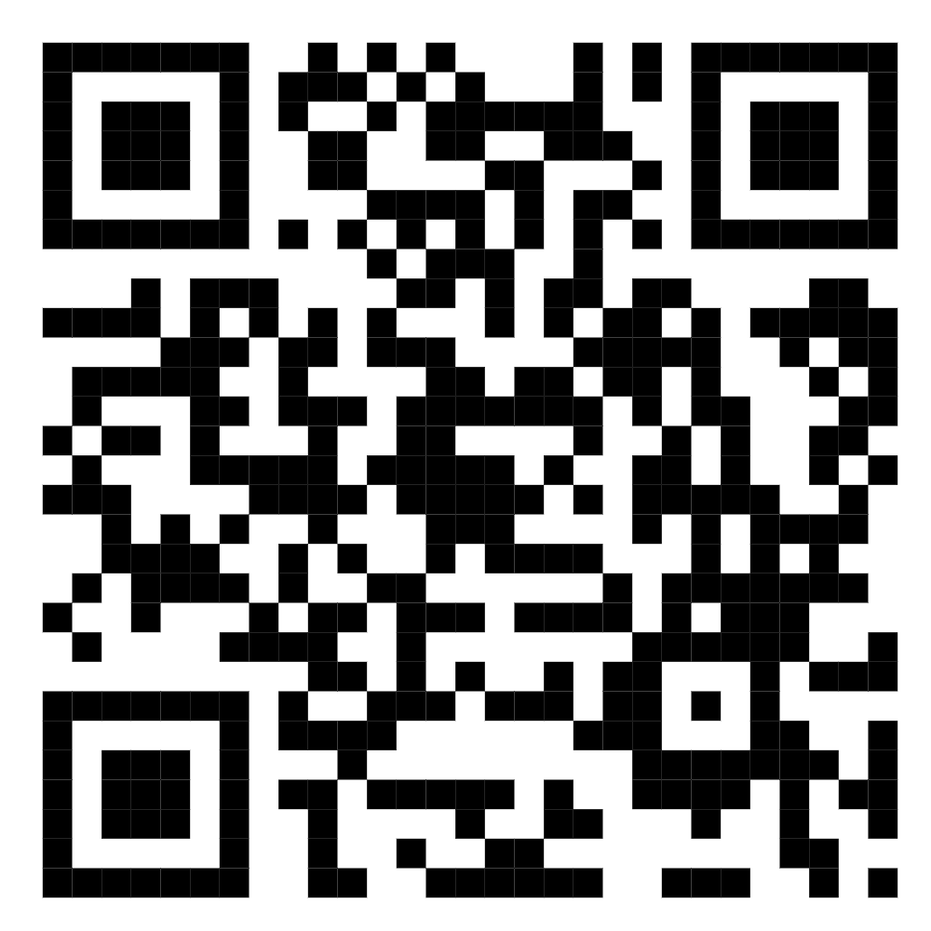
Figure 2: Vocational School of Health Services Student Exam Evaluation Survey QR code

